[Document subtitle]

**Audio amplifier report**

**عمل الطلاب: -**

**احمد زكريا عبد العال يوسف**

**علي عبد المنعم علي**

**رحمه احمد يوسف امين**

**ايثار عدنان ابراهيم البليدي**

**اسراء مجدي محمد نجيب**

**مادة اختبارات 1**

**م: منار أسامة**

**م: بسمة محمد**

**د: طارق الكمار**

**Equipment: -**

**1-speaker 4-ohm 5w**

**2- 10-ohm resistor**

**3-lm 386-n1 ic**

**4-wires**

**5-pot resistor 10 k ohm**

**6-470 uf capacitor**

**7-33 uf capacitor**

**8- jack 3.5mm**

**9-capacitor 10uf**

**10-capacitor 47 nano farad**

**11-capacitor 100 nano farad**

**12- DC source 5v**

**Circuit connection: -**

**Explain the circuit:**

**-when we connect an audio jack and playing audio, we see the audio is increased**

**-we can control the audio level using pot resistor**

**- when we connect the oscilloscope, we see the output wave is increased**

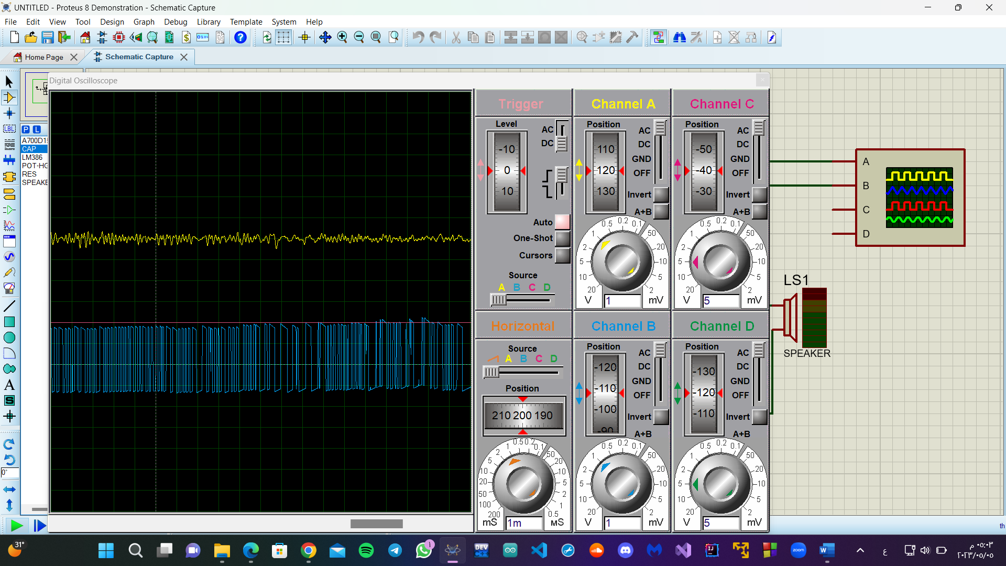

**How the circuit work: -**

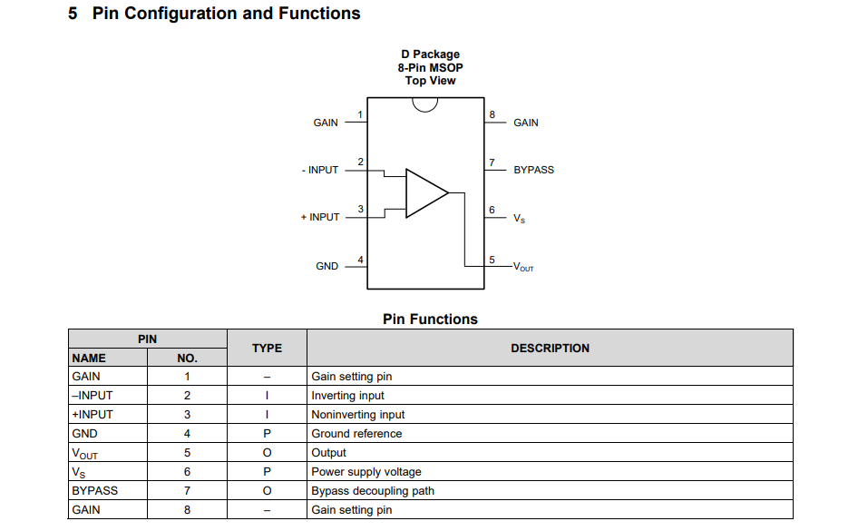

**-ic l86 consists of 8 pins**

**-IC 386 consists of a network of transistors, which in turn amplify the input signal from input No. 3 to output No. 5**

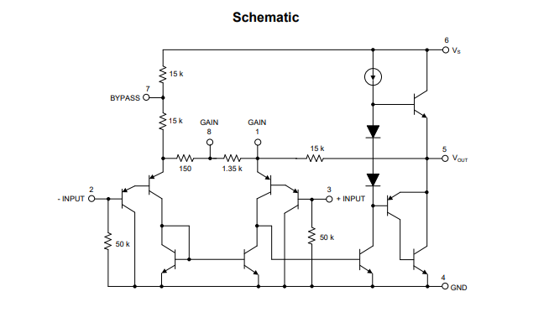

**-A 10 microfarad capacitor is placed on terminals IC 1 and 8 to amplify the sound 200 times**

**-without 10uf capacitor sound is amplifying only 20 times.**

**-100 nano farad capacitor is using for filtering the input signal from noise.**

**-when we read the data sheet, we will know why we chosen these values.**

**-pin no 2 is a -ve input pin and pin no 3 is a +ve input pin.**

**-pin no 5 is output pin.**

**-pin no 6 is a supplying pin.**

**-pin no 4 is connected to ground.**

**-33uf capacitor is using for filtering the sound.**

**-50nf capacitor and 10r resistor using to dampen the vibrations**

**-470uf capacitor used for filtering the output signal.**